Cairo University Faculty of Computers and Artificial Intelligence



**Advanced SE**

**Software design specification document**

**2022**

**Project Team**

|  |  |  |
| --- | --- | --- |
| **ID** | **Name** | **Email** |
| 20201115 | Abdallah mohammed abdul-rhem | body5401@gmail.com |
| 20200050 | Ahmed Mohammed Hany | ahmedhany20200050@gmail.com |
| 20200298 | Abdel-salam saeed abdel-salam | abdelalamsaeed01@gmail.com |
| 20200203 | Zeyad farag | asdanazeyadandali545@gmail.com |

Contents

Class diagram design 2

Class diagram Explanation 3

Sequence diagram design 4

Github repository link 4

# Class diagram design

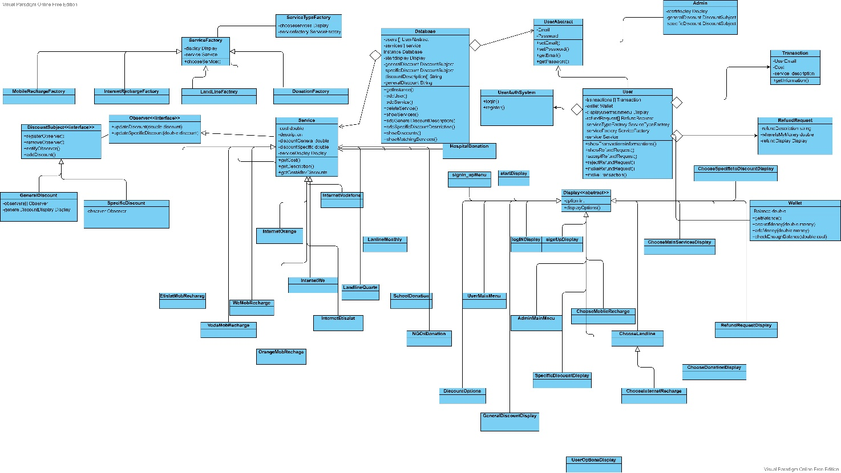

# 

# Class diagram Explanation

* **Explain here the design pattern(s) that you used and your justification for using them, and the participating classes for each pattern.**

**Singleton pattern:**

1. **We needed a single database for system**

**Participating classes: database**

1. **We needed a single object for each service**

**EtislatMobRechareg,VodaMobRecharge,WeMobRecharge,InternetOrange,InternetWe,OrangeMobRecharge,InternetEtisalat,LandlineQuarte,LandlineMonthly…etc**

* **Strategy Pattern**

**Used in displays classes in the system, as every display has the same function but can diverse depending on where it will be used (admin menu, user main menu, choose services display, etc).**

* **Observer Design pattern**

**Used to help us add discounts to the services, as we register the services to the discount subject (for example GeneralDiscountSubject class) then when we add a discount the subject will notify the services and update the value of discount in them.**

* **Factory Design pattern**

**We used it to help us selecting the service the user wants to use depending on the options he chooses, as we have at first a service type factory which selects one of the following factories (Mobile Recharge factory, Donation Factory, etc), and the factory we select it will return specific service the user want to use (for example, in mobile recharge factory, the user will choose Etisalat recharge, we recharge, Vodafone recharge and Orange recharge).**

# Sequence diagram design

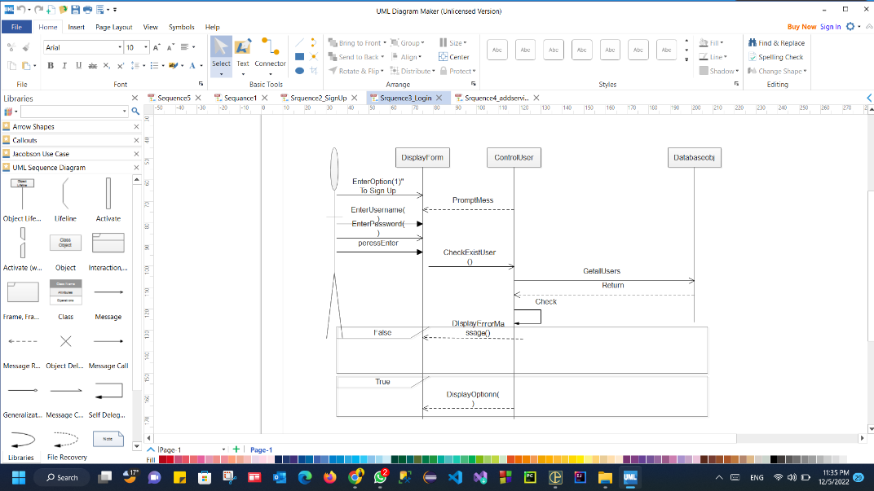

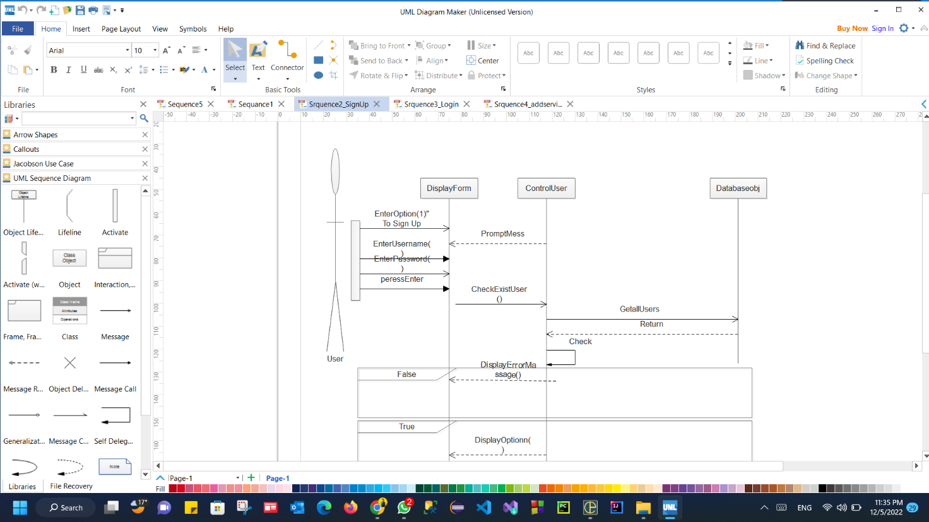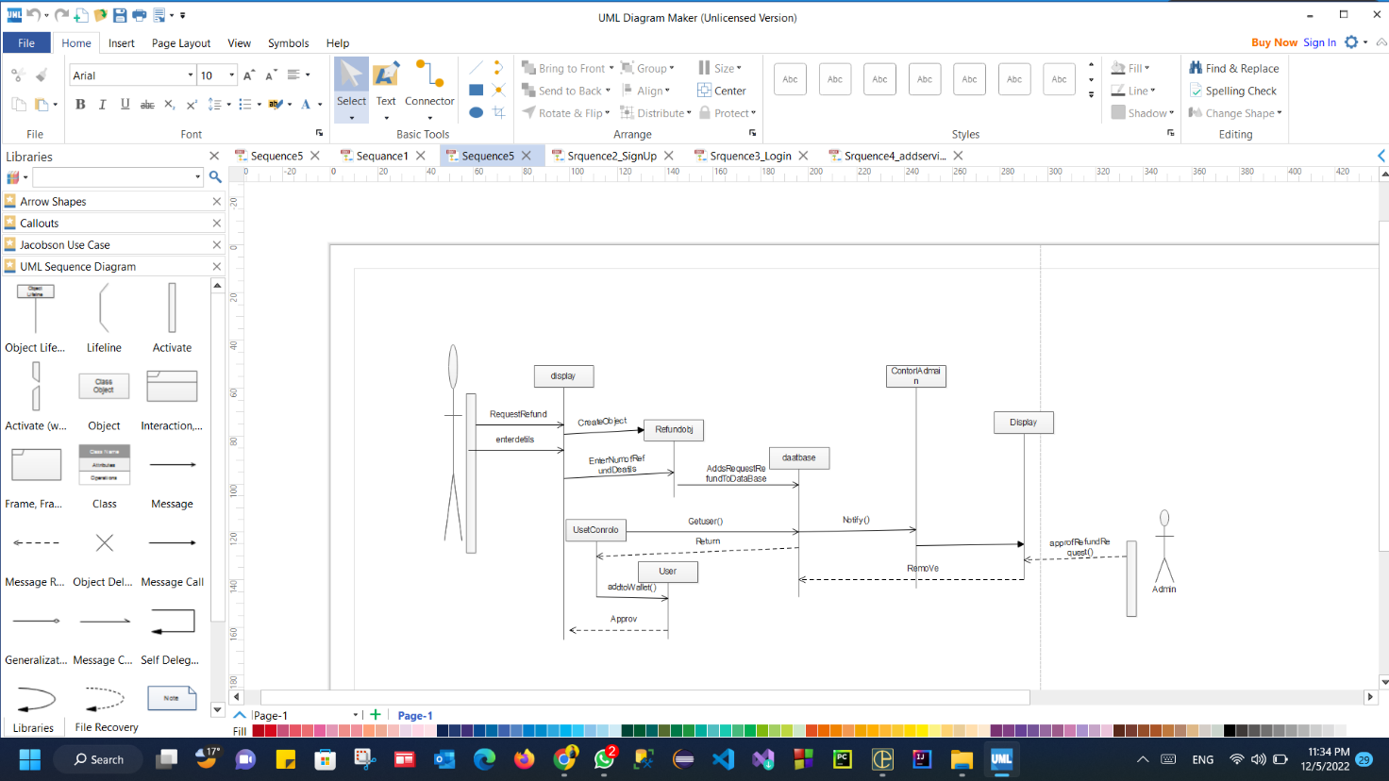

# 

# Schematic Description automatically generated with medium confidenceDiagram Description automatically generated with low confidenceDiagram, schematic Description automatically generatedDiagram, schematic Description automatically generatedDiagram, schematic Description automatically generated

# Github repository link

* <https://github.com/abdulla54abdulrhem/SW_temp>